Length

Definition
# Source: AI Source: Provided by: [Data Path: Persons Table -> ID Column: 1, Name_En Column: Motasem Essam] -> From: [ChatGPT] on [7/20/2026]
In geometry, length is the linear distance between two points, endpoints, or boundaries measured along a specified direction or path.
In simple terms:
Length describes how long a geometric object or segment is.
$$\boxed{\text{Length}=\text{Linear Distance}}$$
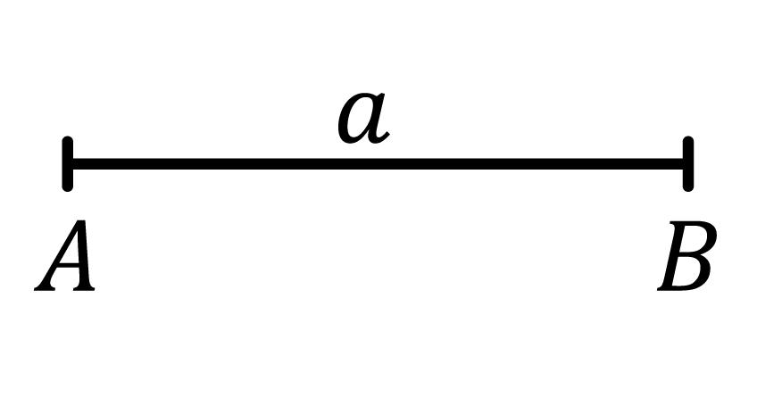
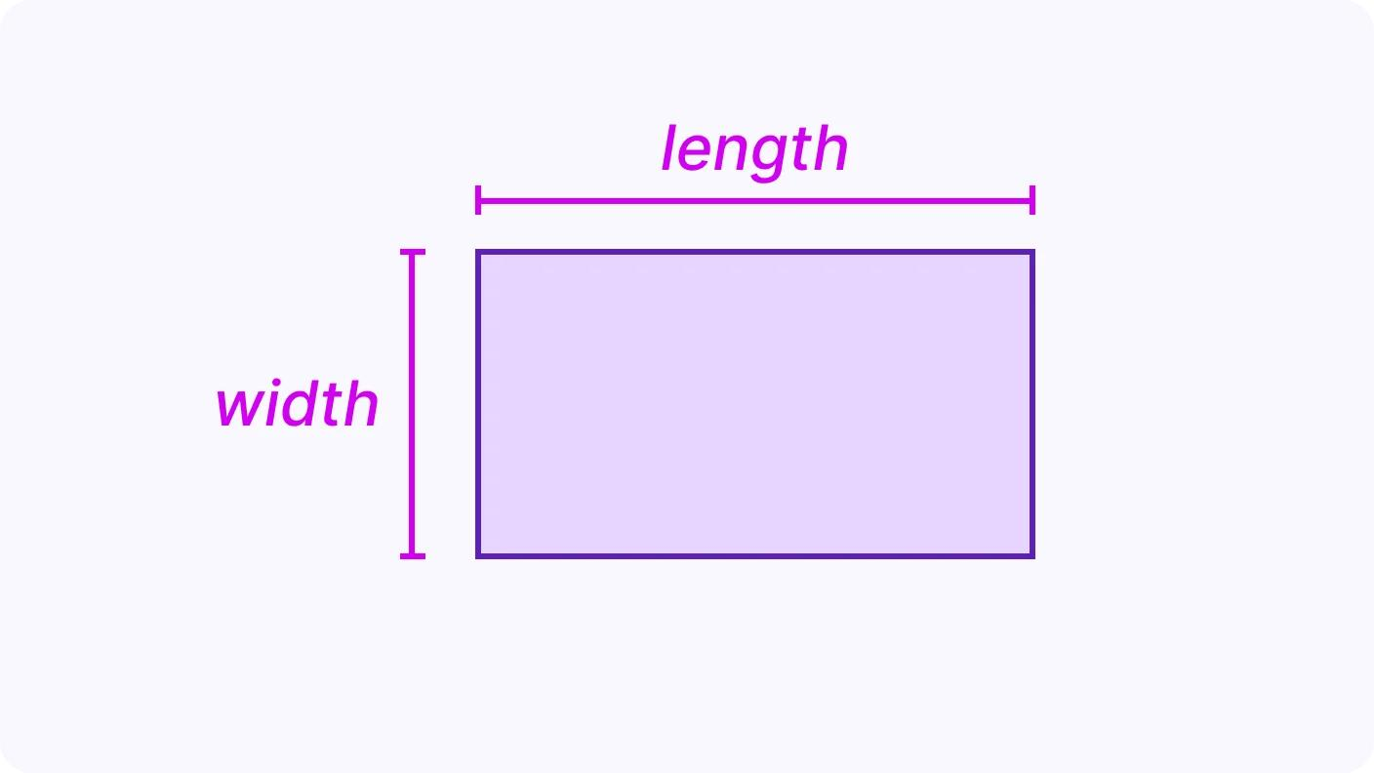
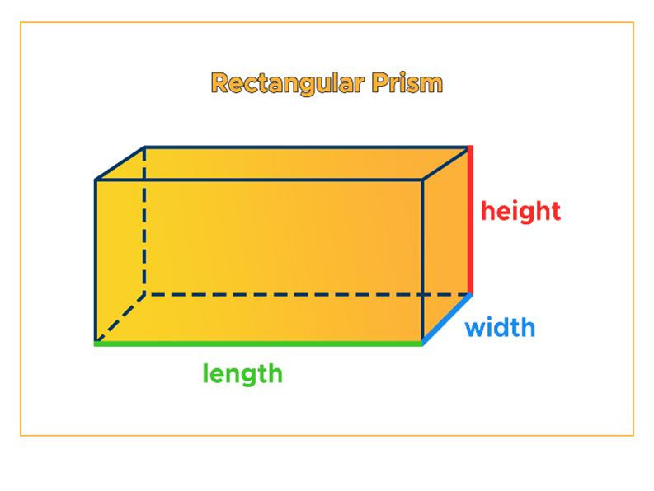
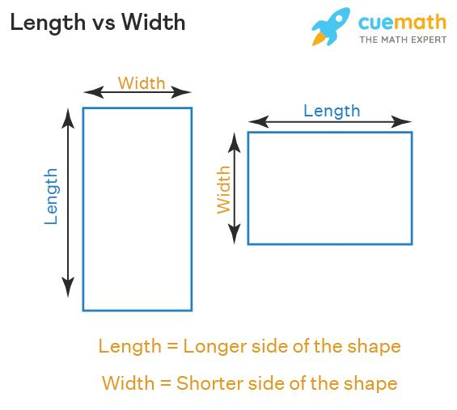
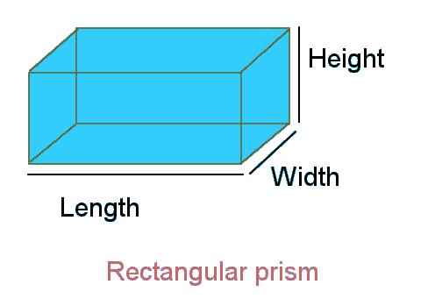

Characteristics
# Source: AI Source: Provided by: [Data Path: Persons Table -> ID Column: 1, Name_En Column: Motasem Essam] -> From: [ChatGPT] on [7/20/2026]
Length:
- Is a linear measurement.
- Measures the extent of an object from one point or side to another.
- Is commonly represented by $l$.
- Is measured in linear units.
- Can describe a line segment, side, edge, object, or path.
- Is used in calculations involving perimeter, area, surface area, and volume.
$$\boxed{l≥0}$$

Length of a Line Segment
# Source: AI Source: Provided by: [Data Path: Persons Table -> ID Column: 1, Name_En Column: Motasem Essam] -> From: [ChatGPT] on [7/20/2026]
For a line segment with endpoints (A) and (B), its length is the distance between the two endpoints:
$$\boxed{L=AB}$$
If the endpoints have coordinates
$$A\left(x_{1},y_{1}\right), B\left(x_{2},y_{2}\right)$$
then:
$$\boxed{AB=\sqrt{{\left(x_{2}-x_{1}\right)}^{2}+{\left(y_{2}-y_{1}\right)}^{2}}}$$
For a horizontal segment:
$$L=\left|x_{2}-x_{1}\right|$$
For a vertical segment:
$$L=\left|y_{2}-y_{1}\right|$$

Length in Plane Geometry

1. Rectangle
# Source: AI Source: Provided by: [Data Path: Persons Table -> ID Column: 1, Name_En Column: Motasem Essam] -> From: [ChatGPT] on [7/20/2026]
The length is commonly the longer dimension of a rectangle.
$$\boxed{A=lw}$$
where:
- $l$ = length
- $w$ = width
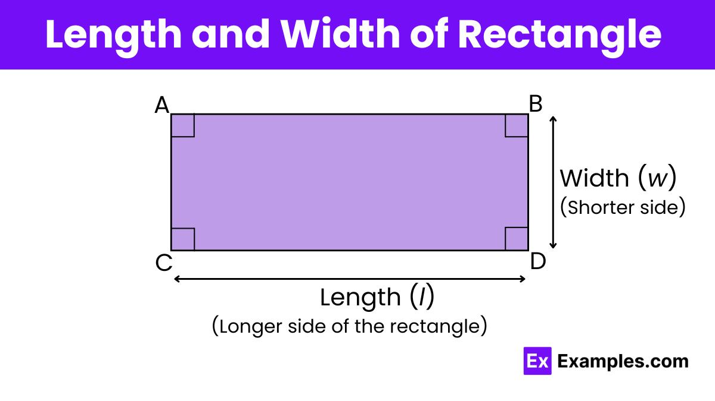
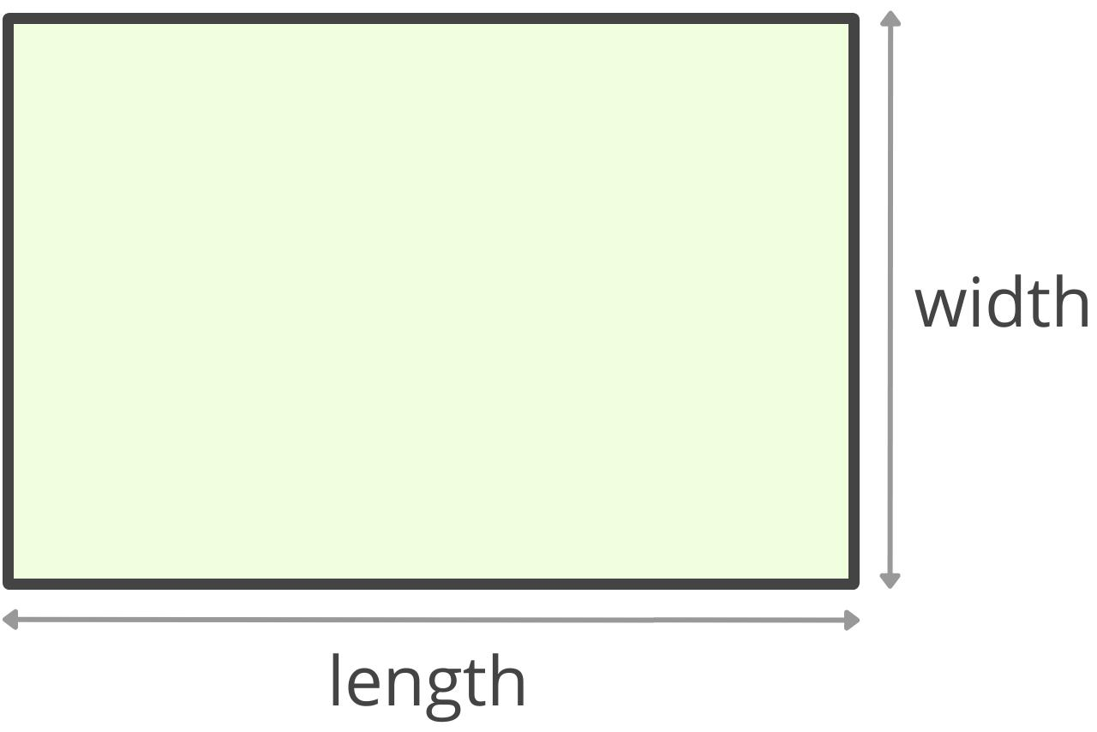
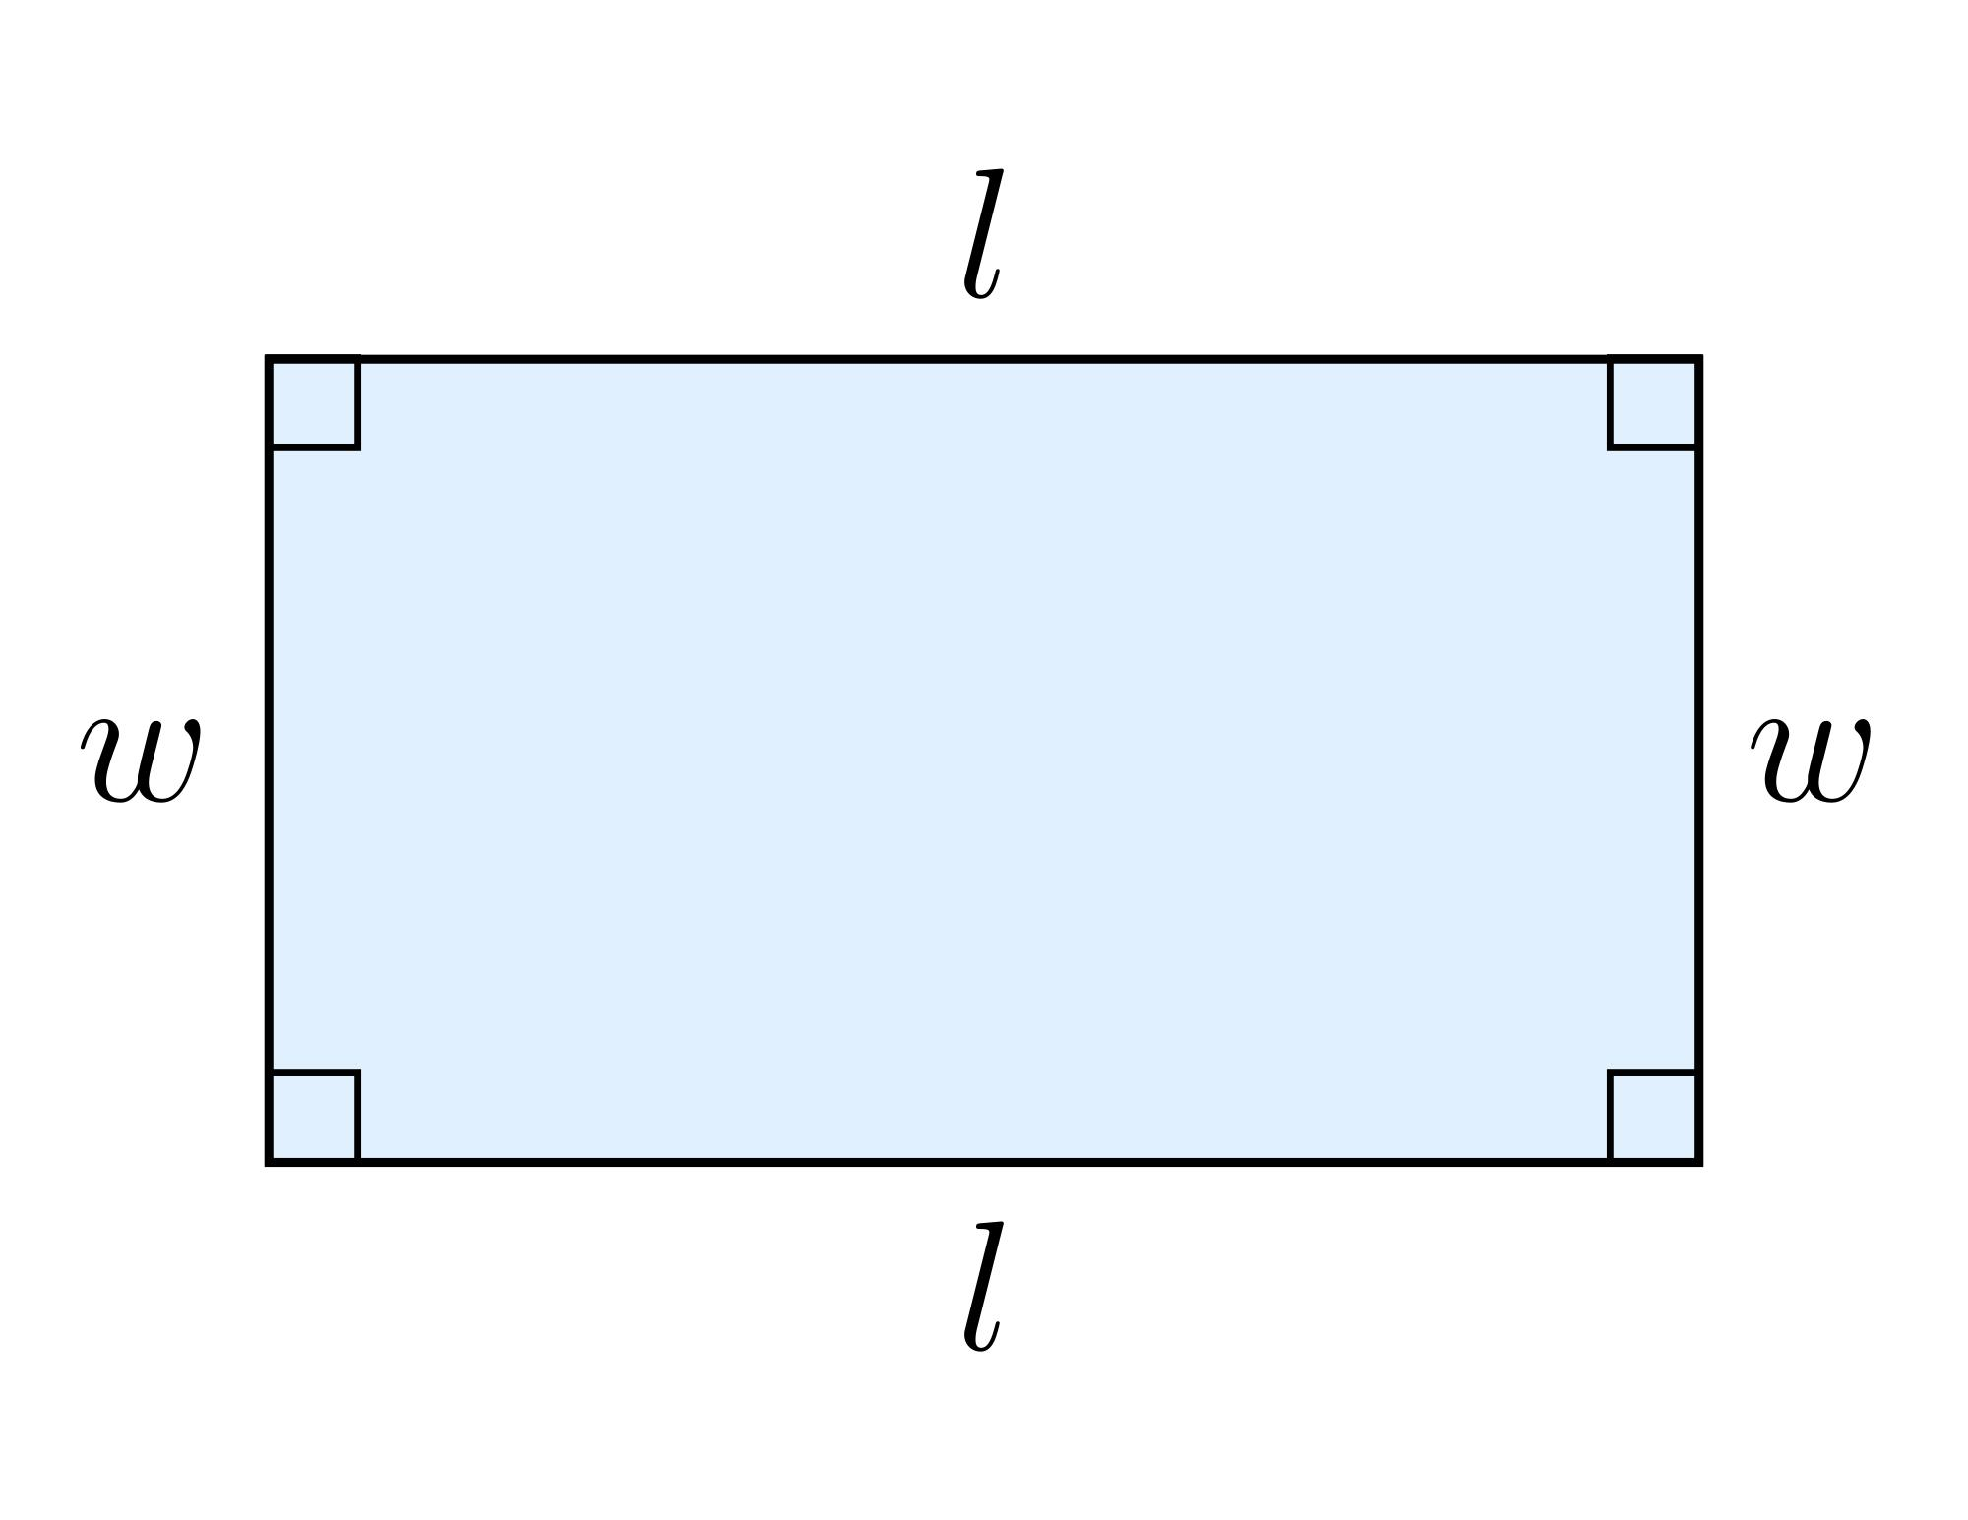
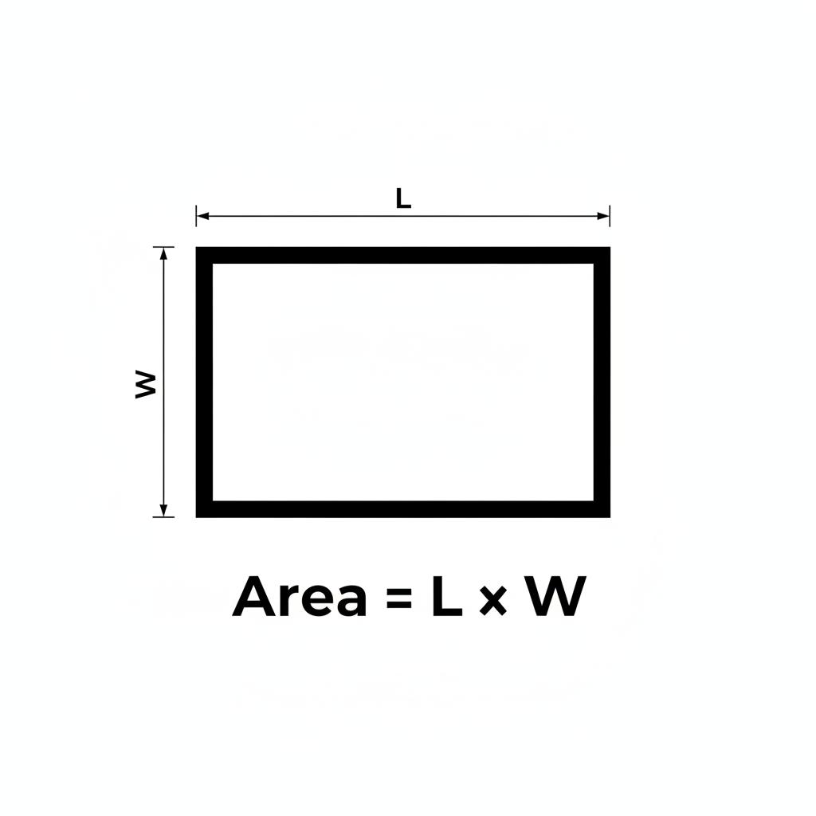

The perimeter is:
$$\boxed{P=2\left(l+w\right)}$$

2. Square
# Source: AI Source: Provided by: [Data Path: Persons Table -> ID Column: 1, Name_En Column: Motasem Essam] -> From: [ChatGPT] on [7/20/2026]
A square has four equal side lengths:
$$\boxed{l=w=s}$$
Its area is:
$$A=s^{2}$$
and its perimeter is:
$$P=4s$$
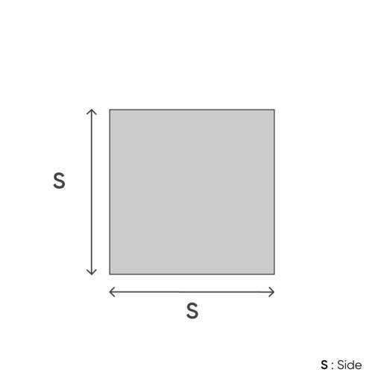
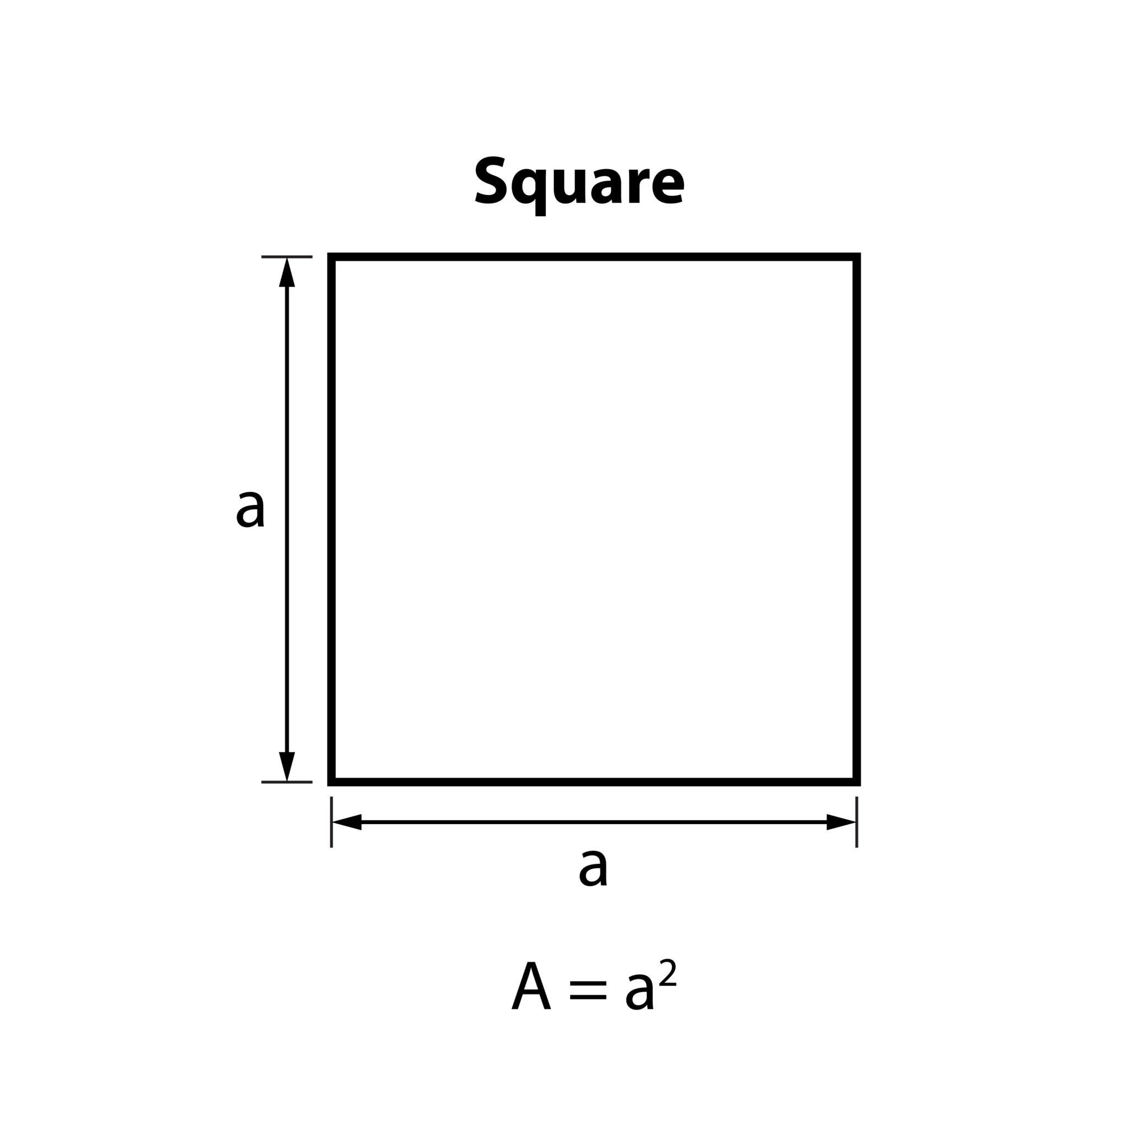
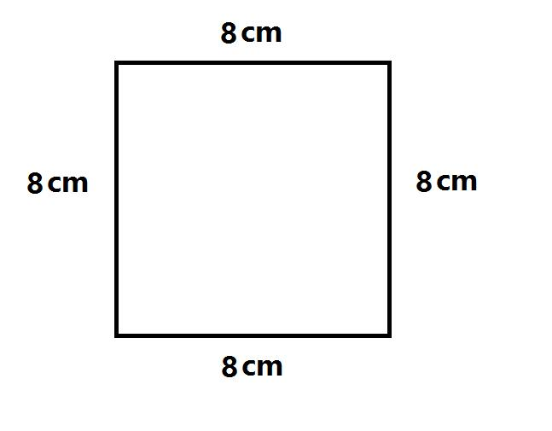
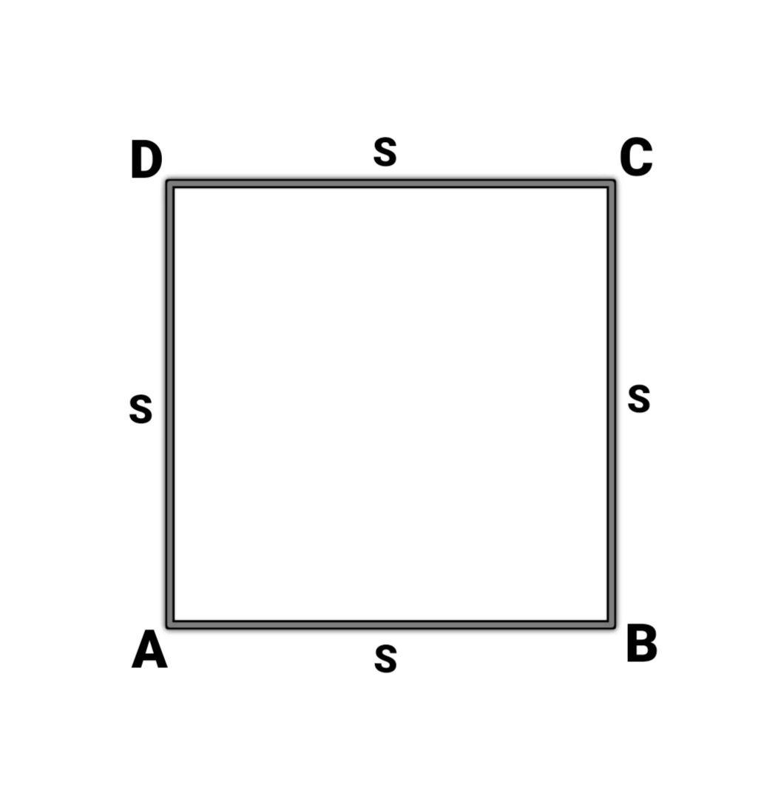

3. Triangle
# Source: AI Source: Provided by: [Data Path: Persons Table -> ID Column: 1, Name_En Column: Motasem Essam] -> From: [ChatGPT] on [7/20/2026]
Each side of a triangle has a length:
$$a, b, c$$
The perimeter is:
$$\boxed{P=a+b+c}$$
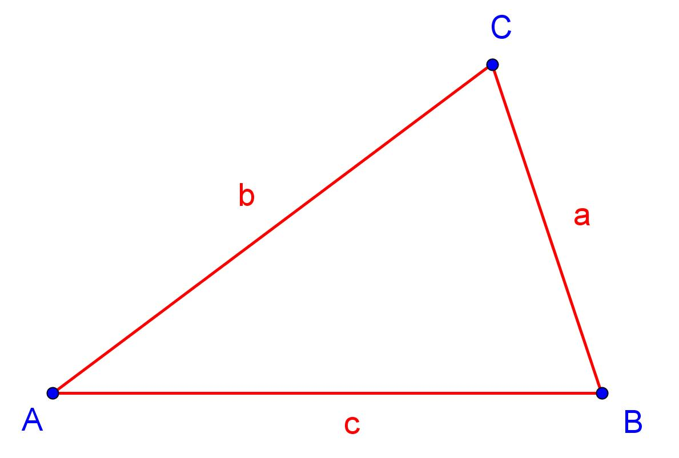
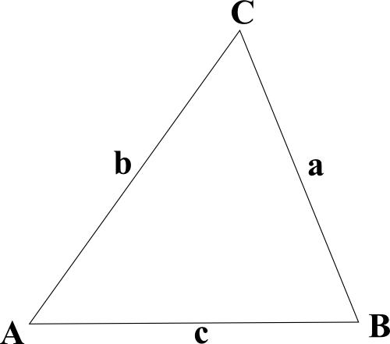
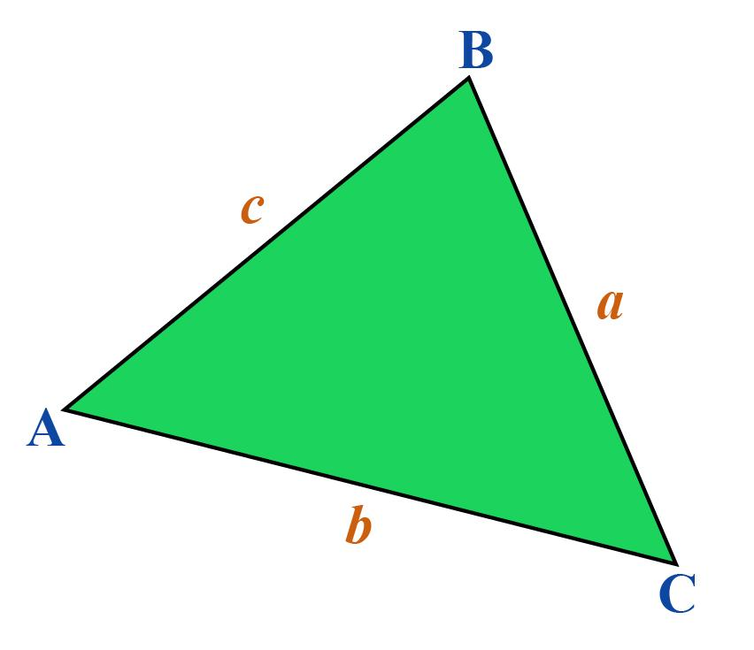
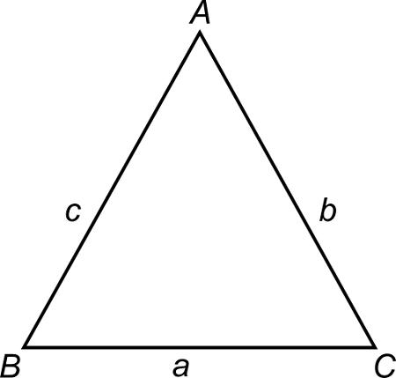
The longest side of a right triangle is the hypotenuse.

Length in Solid Geometry
# Source: AI Source: Provided by: [Data Path: Persons Table -> ID Column: 1, Name_En Column: Motasem Essam] -> From: [ChatGPT] on [7/20/2026]
For a 3D object, length is one of the dimensions describing its spatial extent.

Rectangular Prism
# Source: AI Source: Provided by: [Data Path: Persons Table -> ID Column: 1, Name_En Column: Motasem Essam] -> From: [ChatGPT] on [7/20/2026]
A rectangular prism commonly has:
$$\boxed{V=lwh}$$
where:
- $l$ = length
- $w$ = width
- $h$ = height

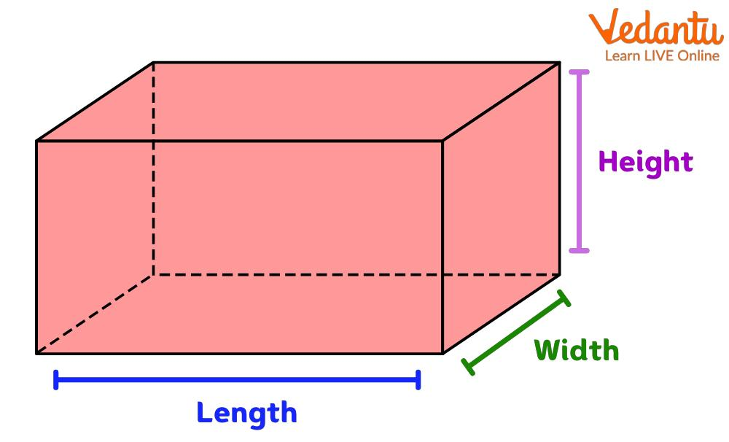
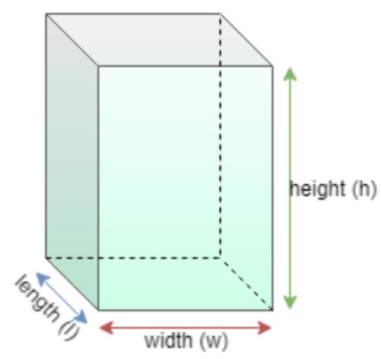
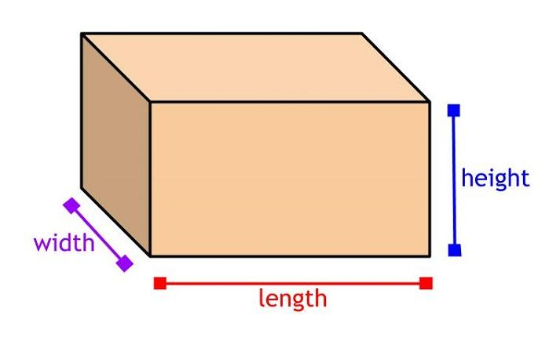
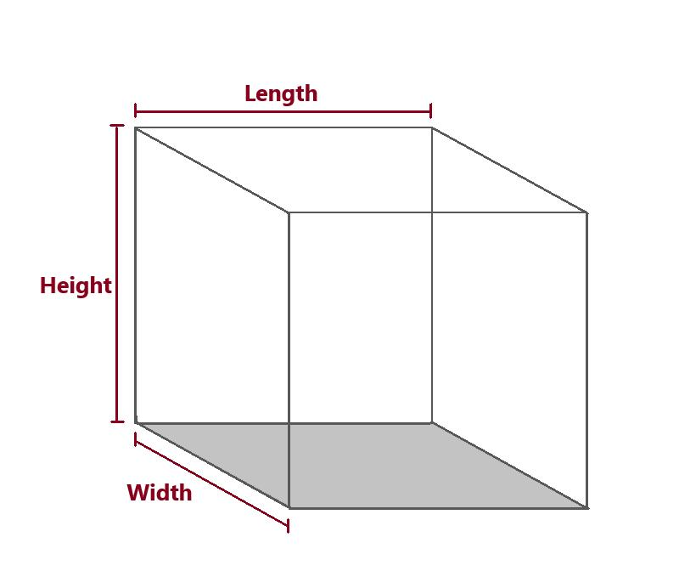
The surface area is:
$$\boxed{SA=2\left(lw+lh+wh\right)}$$

Length and Area
# Source: AI Source: Provided by: [Data Path: Persons Table -> ID Column: 1, Name_En Column: Motasem Essam] -> From: [ChatGPT] on [7/20/2026]
For a rectangle:
$$\boxed{A=lw}$$
If the width remains constant, increasing the length increases the area proportionally.
For example, if:
$$w=5$$
then:
$$A=5l$$
Therefore:
$$l=2⇒A=10$$
and:
$$l=8⇒A=40$$

Length and Perimeter
# Source: AI Source: Provided by: [Data Path: Persons Table -> ID Column: 1, Name_En Column: Motasem Essam] -> From: [ChatGPT] on [7/20/2026]
For a rectangle:
$$\boxed{P=2\left(l+w\right)}$$
Solving for length:
$$\boxed{l=\frac{P}{2}-w}$$
Thus, length can be determined when the perimeter and width are known.

Length vs. Width
# Source: AI Source: Provided by: [Data Path: Persons Table -> ID Column: 1, Name_En Column: Motasem Essam] -> From: [ChatGPT] on [7/20/2026]
Both are linear dimensions, but they normally describe different directions.
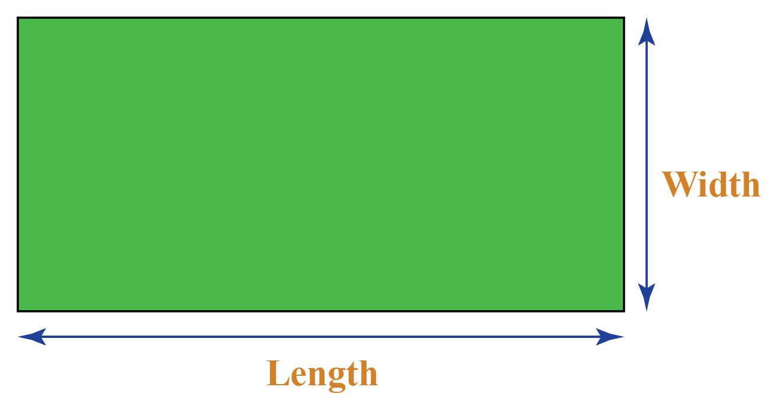
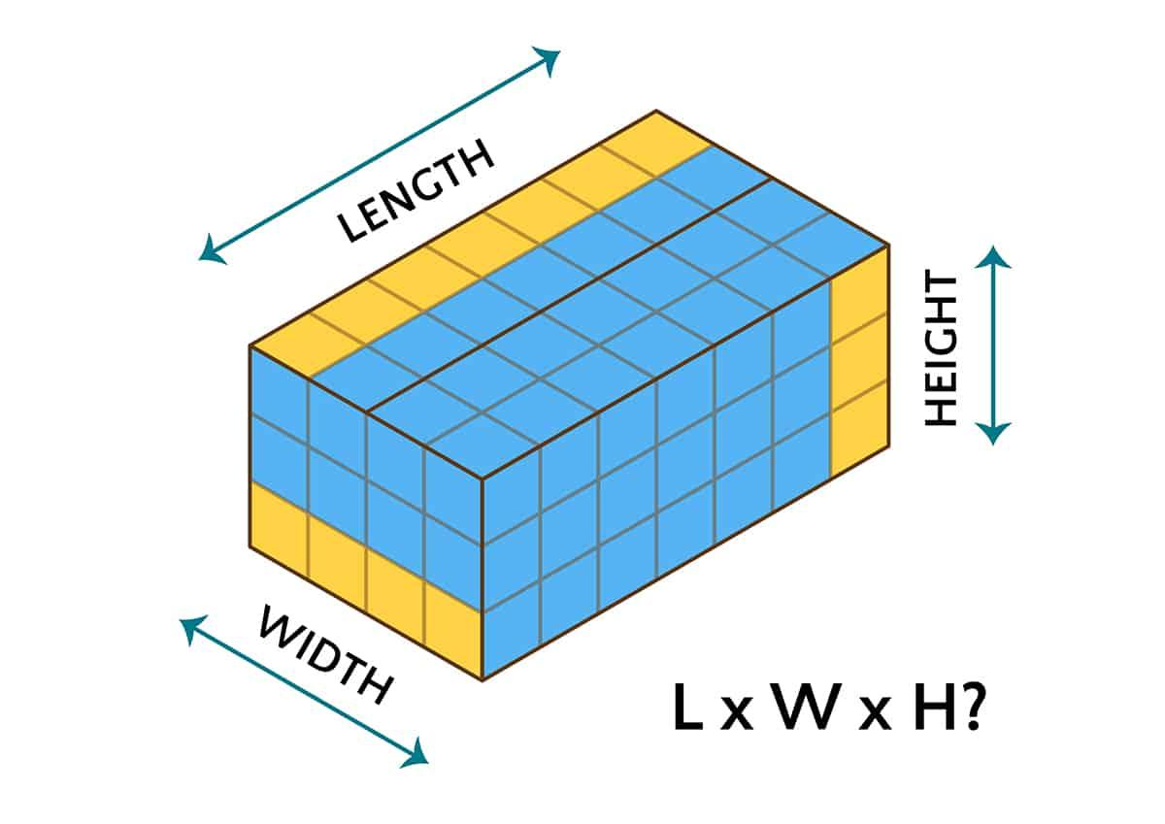
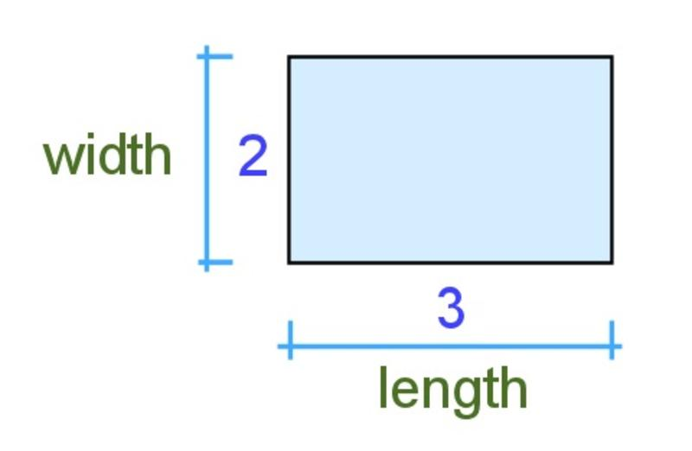
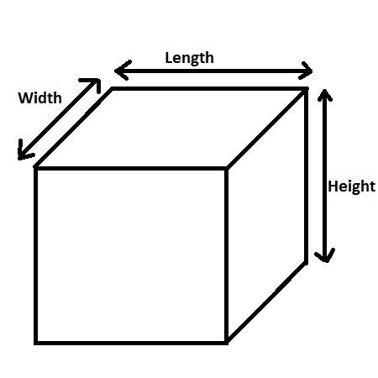
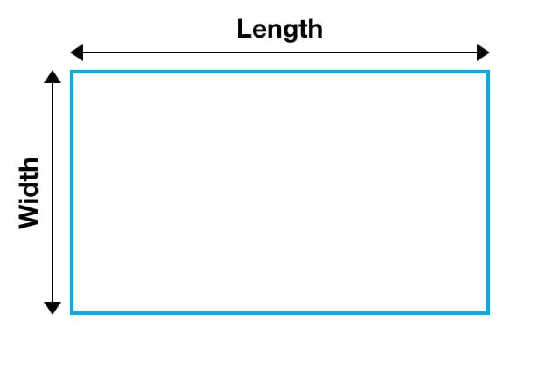
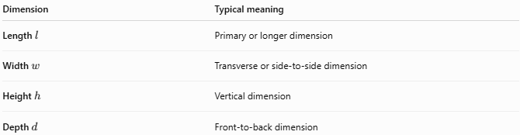
Dimension | Typical meaning
Length $l$ | Primary or longer dimension
Width $w$ | Transverse or side-to-side dimension
Height $h$ | Vertical dimension
Depth $d$ | Front-to-back dimension
These names are conventional. Rotating an object can change which dimension is naturally described as its length.

Length vs. Height
# Source: AI Source: Provided by: [Data Path: Persons Table -> ID Column: 1, Name_En Column: Motasem Essam] -> From: [ChatGPT] on [7/20/2026]
Length and height are both linear measurements, but they generally refer to different directions.
For a rectangular prism:
$$\boxed{V=lwh}$$
Length commonly describes the primary horizontal direction, while height describes the vertical direction.
However, the distinction depends on the orientation and context of the object.

Length vs. Distance
# Source: AI Source: Provided by: [Data Path: Persons Table -> ID Column: 1, Name_En Column: Motasem Essam] -> From: [ChatGPT] on [7/20/2026]
These terms are closely related but are not always interchangeable.
Distance
Distance generally refers to the separation between two points.
$$d\left(A,B\right)$$
Length
Length refers to the size or extent of a geometric object such as a line segment, side, edge, or curve.
For a line segment:
$$\boxed{\text{Length of }AB=\text{Distance from }A\text{ to }B}$$
For a curved path, the distinction becomes more important:
$$\boxed{\text{Curve Length}≠\text{Straight-Line Distance}}$$
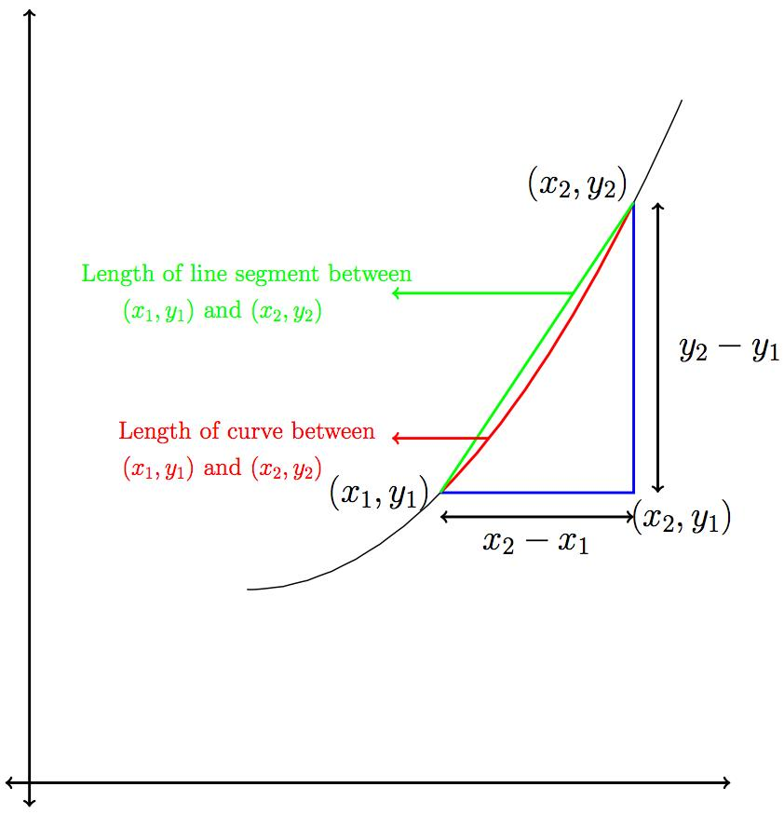
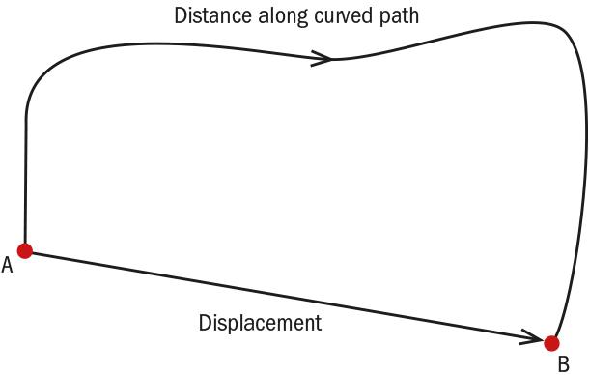
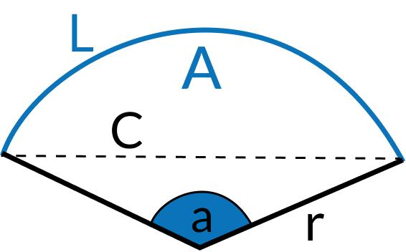

Length of a Curve
# Source: AI Source: Provided by: [Data Path: Persons Table -> ID Column: 1, Name_En Column: Motasem Essam] -> From: [ChatGPT] on [7/20/2026]
A curved object also has a measurable length, called its arc length.
For a parametric curve
$$x=x\left(t\right), y=y\left(t\right)$$
the arc length is:
$$\boxed{L=\int_{a}^{b}{\sqrt{{\left(\frac{dx}{dt}\right)}^{2}+{\left(\frac{dy}{dt}\right)}^{2}}}dt}$$
For a circle, the circumference is its total boundary length:
$$\boxed{C=2πr}$$
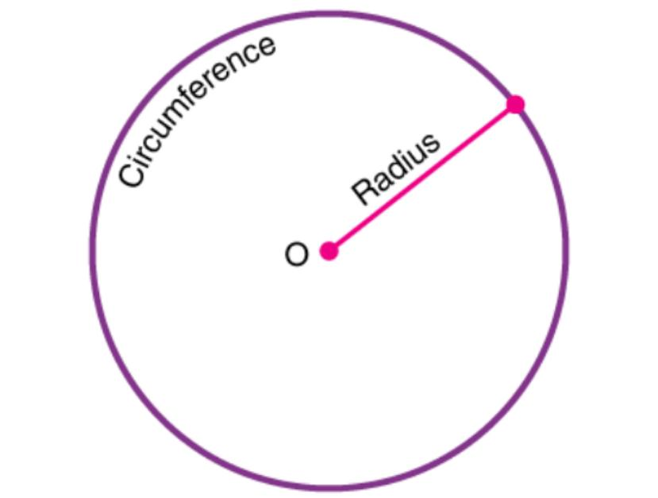
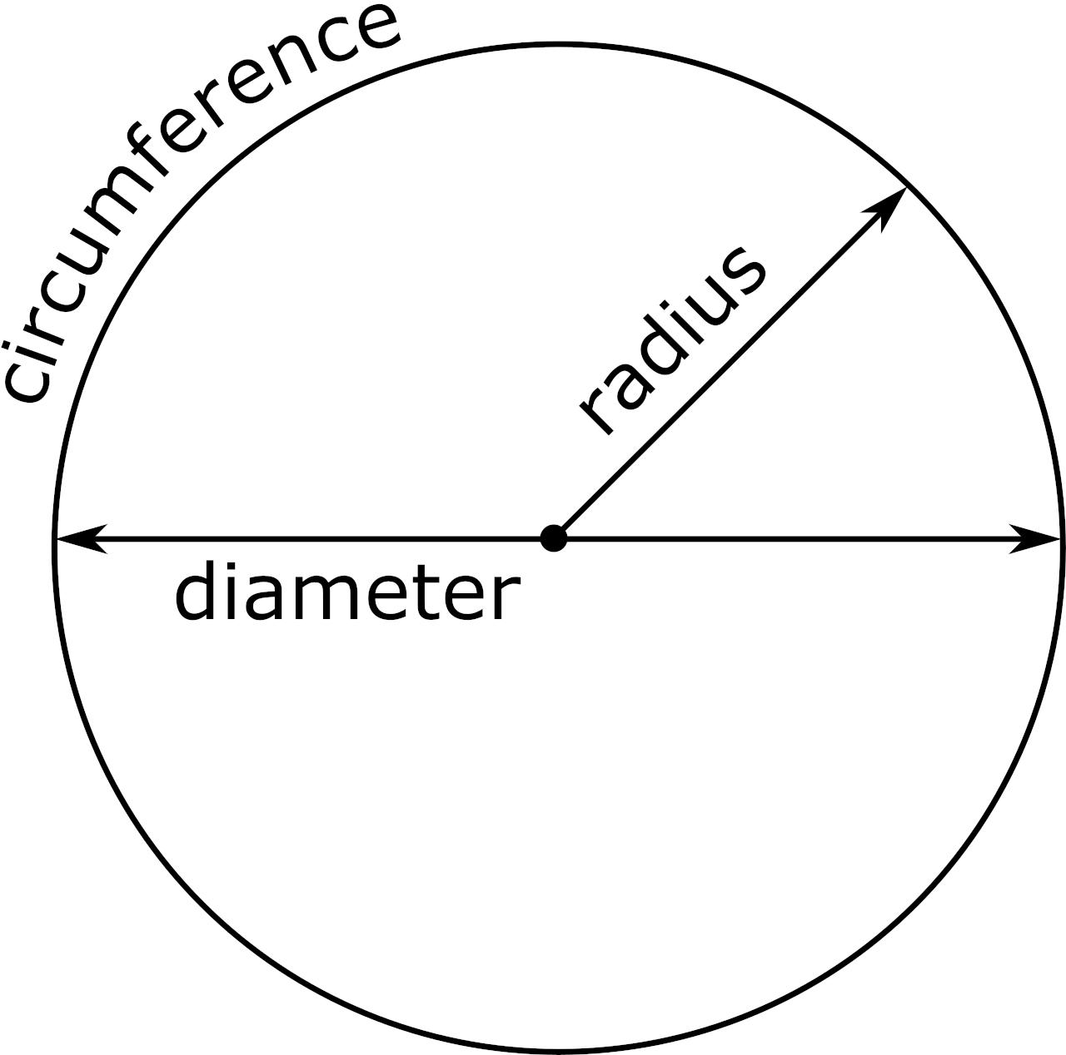
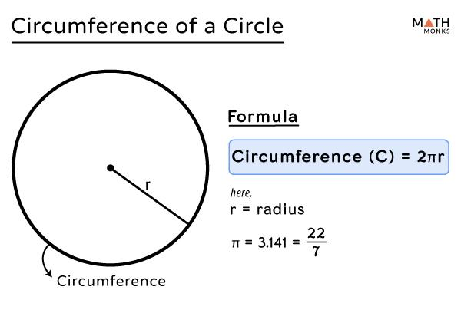
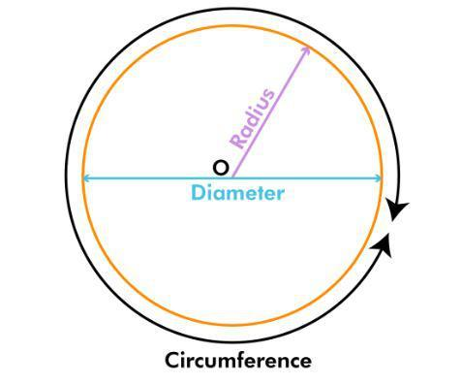

Length in Measurement
# Source: AI Source: Provided by: [Data Path: Persons Table -> ID Column: 1, Name_En Column: Motasem Essam] -> From: [ChatGPT] on [7/20/2026]
Length is a fundamental physical and geometric quantity.
Its dimension is:
$$\boxed{\left[L\right]}$$
Common units include:
- millimeter (mm)
- centimeter (cm)
- meter (m)
- kilometer (km)
- inch (in)
- foot (ft)
- yard (yd)
- mile (mi)
Length must be expressed using linear units.
Correct:
$$l=10\text{ cm}$$
Not:
$$l=10{\text{ cm}}^{2}$$
because ${\text{cm}}^{2}$ is an area unit.

Length in Irregular Shapes
# Source: AI Source: Provided by: [Data Path: Persons Table -> ID Column: 1, Name_En Column: Motasem Essam] -> From: [ChatGPT] on [7/20/2026]
For irregular shapes, there may not be one naturally defined "length."
Depending on the context, one may use:
- Maximum length.
- Minimum length.
- Local length.
- Major-axis length.
- Bounding-box length.
- Path length.
- Perimeter or boundary length.
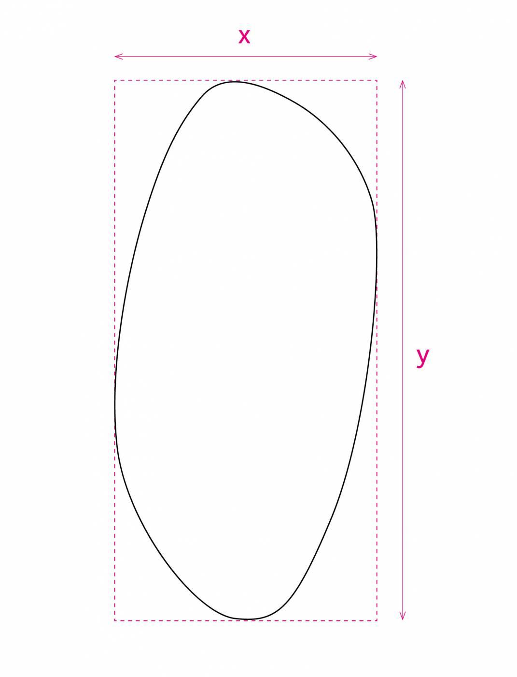
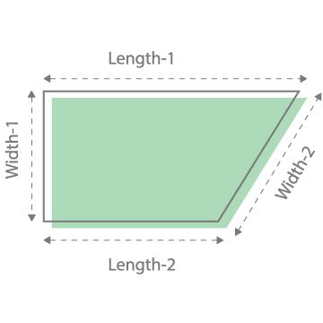
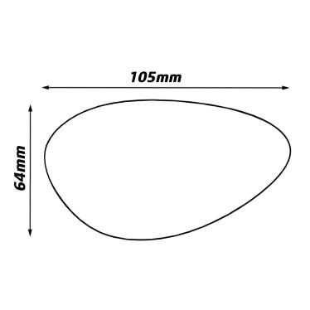
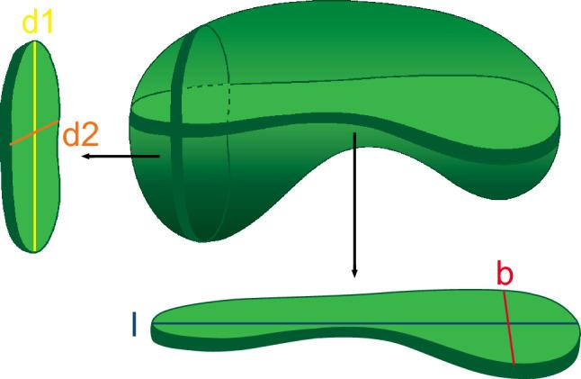
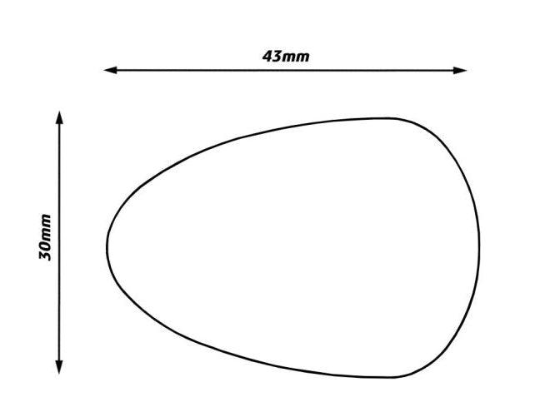
Therefore, for an irregular object, the exact definition of length should be specified.

Applications
# Source: AI Source: Provided by: [Data Path: Persons Table -> ID Column: 1, Name_En Column: Motasem Essam] -> From: [ChatGPT] on [7/20/2026]
Length is important in:
- Geometry
- Measurement Theory
- Engineering
- Architecture
- Technical Drawing
- Mechanical Design
- Construction
- Manufacturing
- Robotics
- Computer Graphics
- CAD (Computer-Aided Design)
- Surveying
- Navigation

Advantages
# Source: AI Source: Provided by: [Data Path: Persons Table -> ID Column: 1, Name_En Column: Motasem Essam] -> From: [ChatGPT] on [7/20/2026]
Understanding length helps to:
- Describe the dimensions of objects.
- Measure distances accurately.
- Calculate perimeter, area, and volume.
- Define geometric relationships.
- Support accurate engineering and architectural designs.
- Determine scale and proportions.
- Analyze geometric figures and structures.

Limitations
# Source: AI Source: Provided by: [Data Path: Persons Table -> ID Column: 1, Name_En Column: Motasem Essam] -> From: [ChatGPT] on [7/20/2026]
Length:
- Describes only one-dimensional extent.
- Does not by itself specify direction or orientation.
- Does not describe the complete position of an object.
- May require clearly defined endpoints or reference points.
- Can require additional measurements for three-dimensional objects.
- Does not describe a rea or volume by itself.

Key Points
# Source: AI Source: Provided by: [Data Path: Persons Table -> ID Column: 1, Name_En Column: Motasem Essam] -> From: [ChatGPT] on [7/20/2026]
$$\boxed{\text{Length}=\text{Linear Extent or Distance}}$$
Length:
- Is a one-dimensional measurement.
- Measures how long something is.
- Is often represented by $l$.
- Is measured in linear units.
- Can describe sides, edges, line segments, arcs, or paths.
- Is used in perimeter, area, surface-area, and volume calculations.
- Can be distinguished from width, height, and depth according to orientation.
- For curves, it can be determined using arc length.

Conclusion
# Source: AI Source: Provided by: [Data Path: Persons Table -> ID Column: 1, Name_En Column: Motasem Essam] -> From: [ChatGPT] on [7/20/2026]
Length in geometry is the linear extent of a geometric object or the distance between its endpoints or boundaries along a specified path. It is one of the fundamental dimensions used to describe geometric figures and solids. Length is essential for calculating perimeter, area, surface area, volume, and arc length, and it is normally measured in linear units such as millimeters, centimeters, meters, inches, or feet. For irregular objects and curves, the term may require a more specific definition, such as maximum length, path length, or boundary length.

